Apply filters to SQL queries

Project description
I am a security professional at a large organization. I recently discovered some potential security issues that involve login attempts and employee machines. My task is to examine the organization’s data in their employees and log_in_attempts tables. The following steps provide examples of how I used SQL with filters to perform security-related tasks.

Retrieve after hours failed login attempts
I recently discovered a potential security incident that occurred after business hours. To investigate this, I needed to query the log_in_attempts table and review after hours login activity. I used filters in SQL to create a query that identifies all failed login attempts that occurred after 18:00.

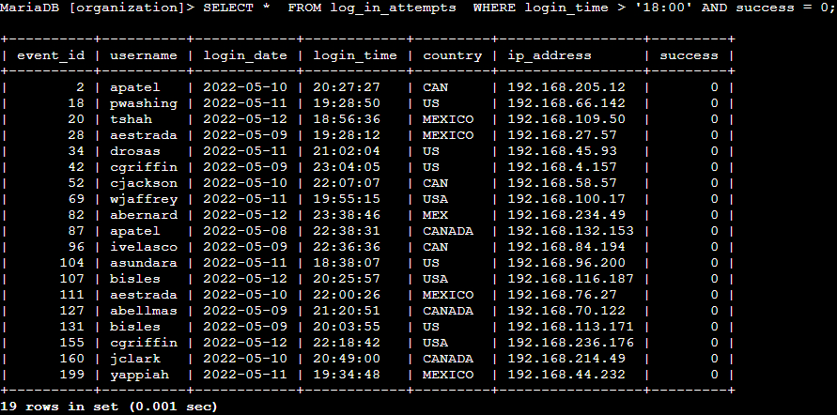
I used the SELECT * query to retrieve all columns from the log_in_attempts table using the filter > for the login_time column (login attempts after business hours), the = filter for the success column (failed login attempts) and the AND clause to combine both conditions. 19 attempts have been recorded outside of business hours, constituting anomalous behavior that could indicate an attacker is attempting to probe for vulnerabilities in the accounts.

Retrieve login attempts on specific dates
A suspicious event occurred on 2022-05-09. To investigate this event, I want to review all login attempts which occurred on this day and the day before. I used filters in SQL to create a query that identifies all login attempts that occurred on 2022-05-09 or 2022-05-08.
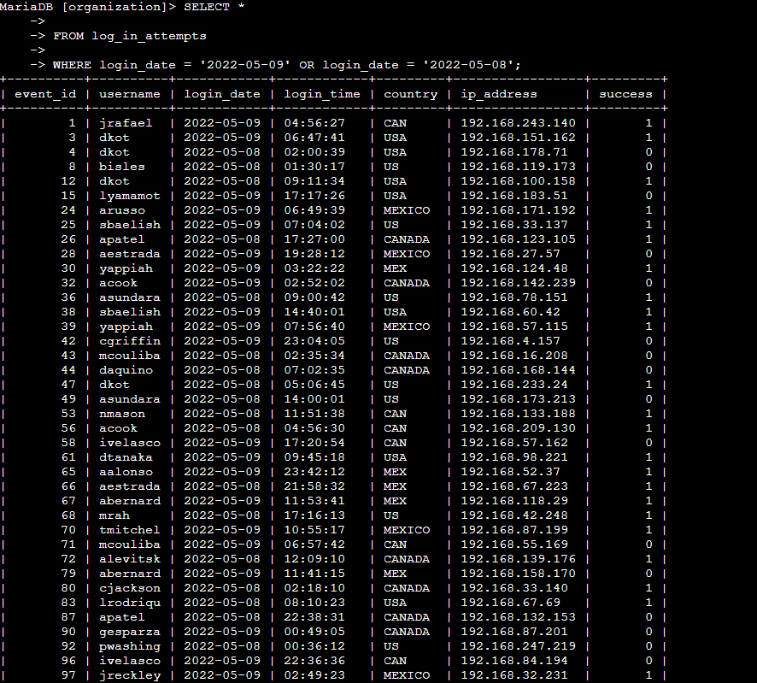

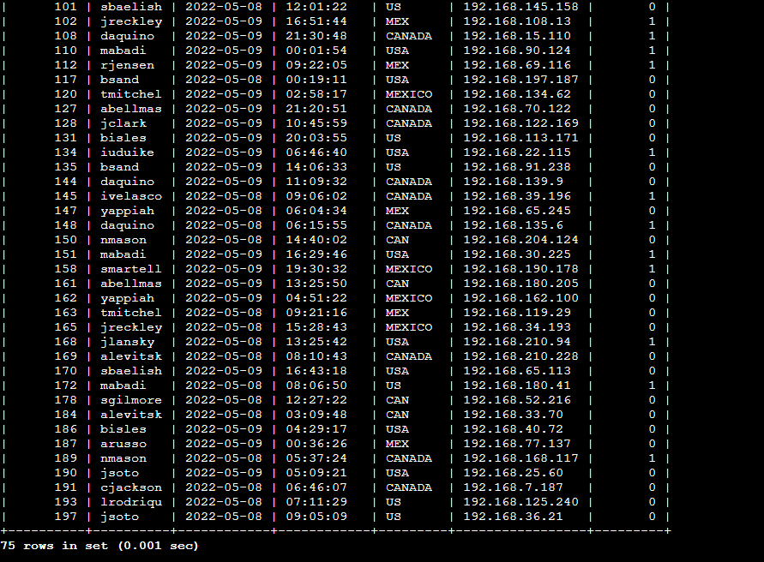

I ran a SELECT * query on the log_in_attempts table, filtering for login dates equal to '2022-05-08' or '2022-05-09' using the OR operator. The first condition is login_date = '2022-05-09', which filters for logins on 2022-05-09. The second condition is login_date = '2022-05-08', which filters for logins on 2022-05-08. This returned a total of 75 login attempts across both dates.

Retrieve login attempts outside of Mexico
There’s been suspicious activity with login attempts, but the team has determined that this activity didn't originate in Mexico. I need to investigate login attempts that occurred outside of Mexico. I used filters in SQL to create a query that identifies all login attempts that occurred outside of Mexico.
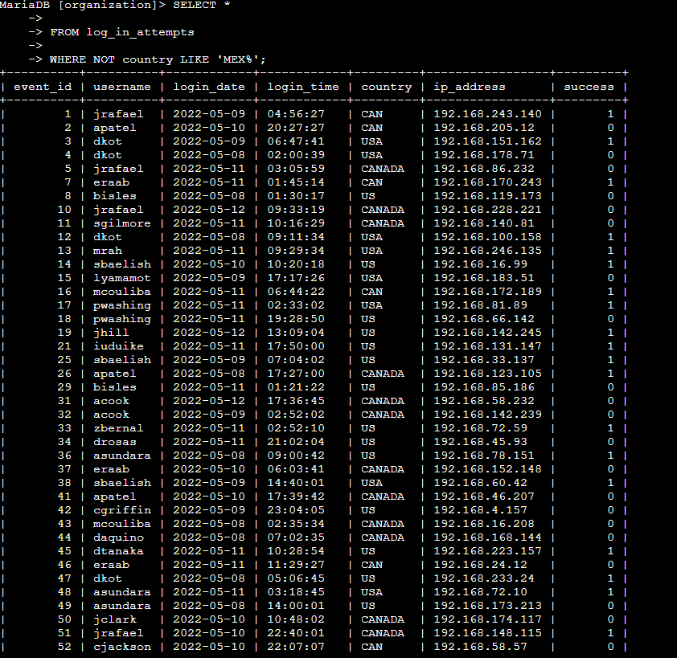
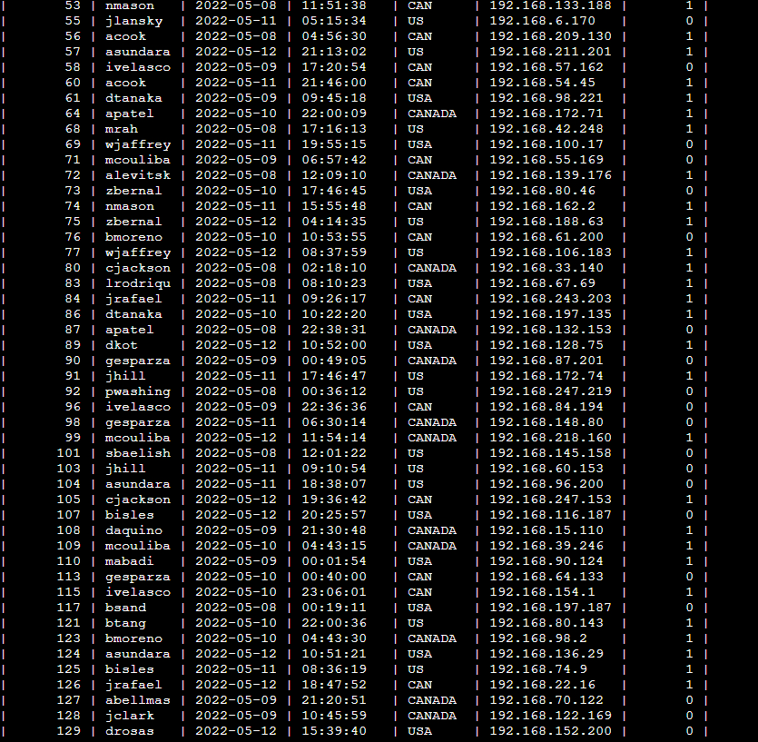
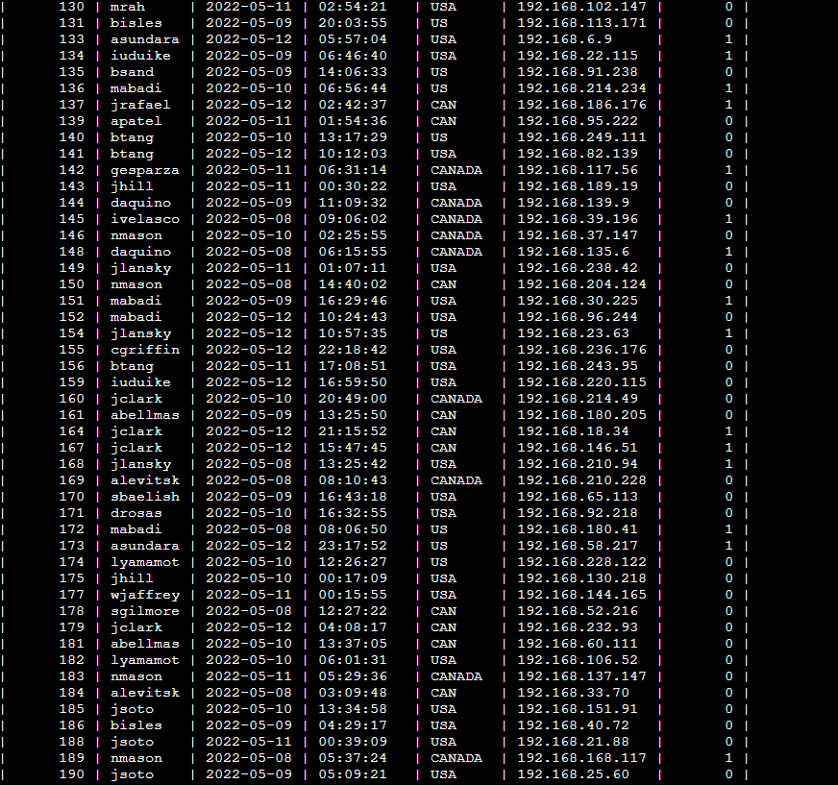
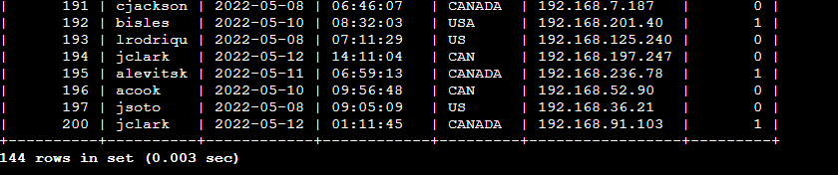

I executed a SELECT * query on the log_in_attempts table to identify activity outside of Mexico. By combining the NOT operator with LIKE 'MEX%', I filtered out all country codes beginning with 'MEX'. The query returned a total of 44 login attempts originating from other regions.

Retrieve employees in Marketing
My team wants to perform security updates on specific employee machines in the Marketing department. I’m responsible for getting information on these employee machines and will need to query the employees table. I used filters in SQL to create a query that identifies all employees in the Marketing department for all offices in the East building.

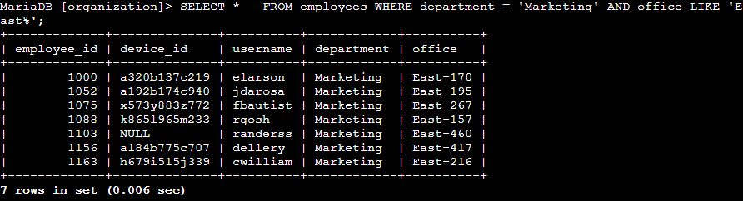

I executed a SELECT * query on the employees table to identify all personnel assigned to the Marketing team located in the East building. To narrow down the results to records meeting both criteria simultaneously, I applied an AND operator combining department = 'Marketing' with office LIKE 'East%' (using the % wildcard to capture all offices within the East building, such as East-101 or East-202). This returned a total of 7 employees who match both conditions.

Retrieve employees in Finance or Sales
My team needs to perform a different security update on machines for employees in the Sales and Finance departments. I used filters in SQL to create a query that identifies all employees in the Sales or Finance departments.
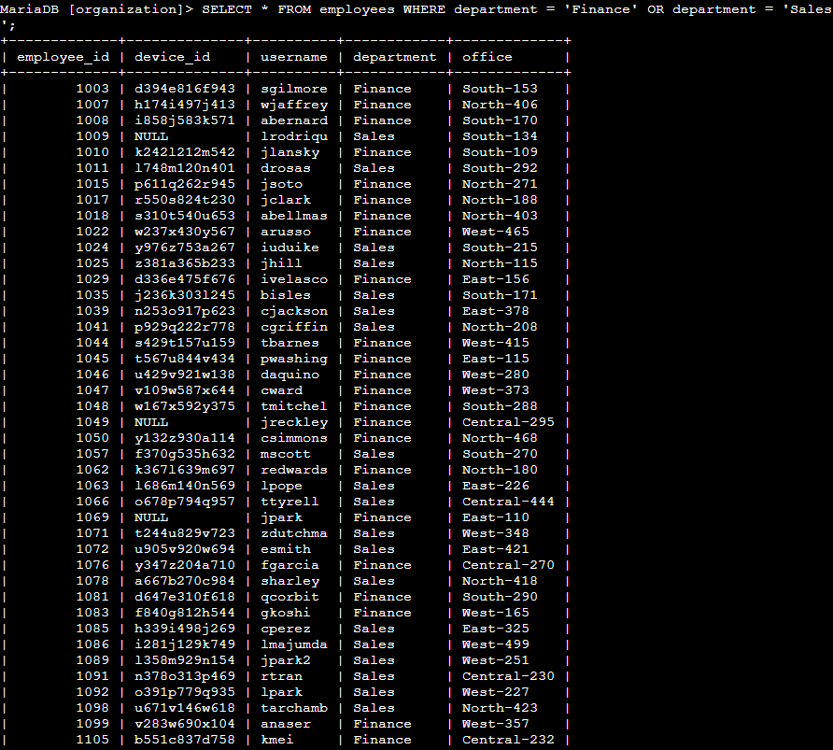
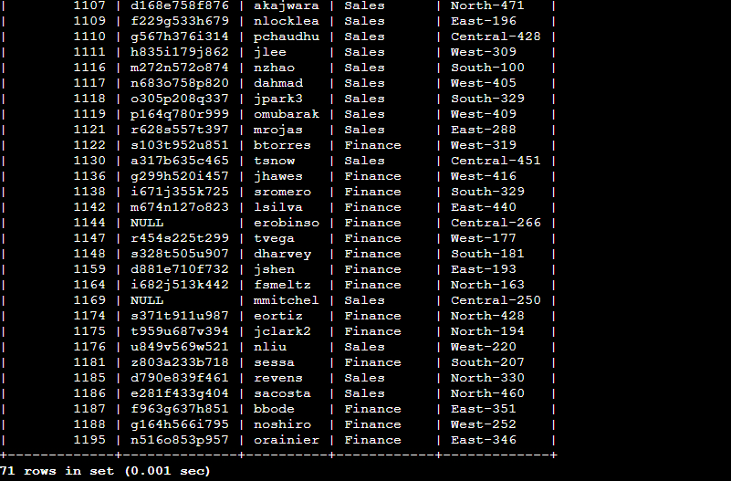

I executed a SELECT * query on the employees table to retrieve all personnel assigned to either the Sales or Finance departments. By applying the condition WHERE department = 'Sales' OR department = 'Finance', I combined both criteria to include staff from either team. The query returned a total of 71 matching employee records.

Retrieve all employees not in IT
My team needs to make one more update to employee machines. The employees who are in the Information Technology department already had this update, but employees in all other departments need it. I used filters in SQL to create a query which identifies all employees not in the IT department.
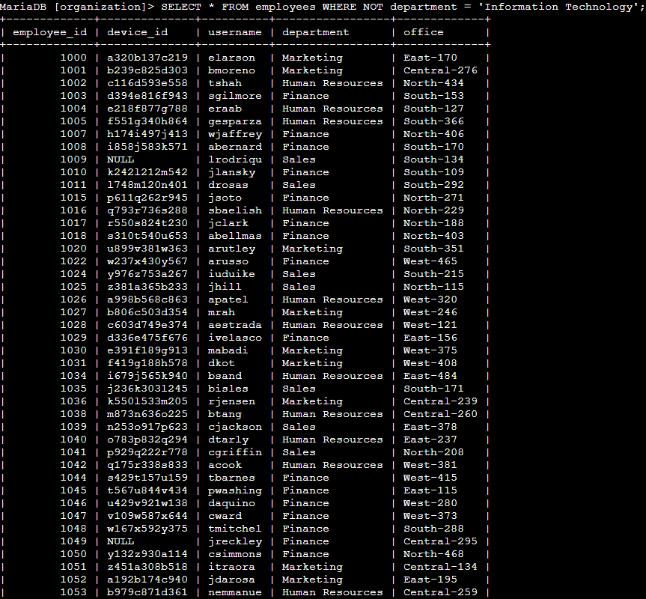
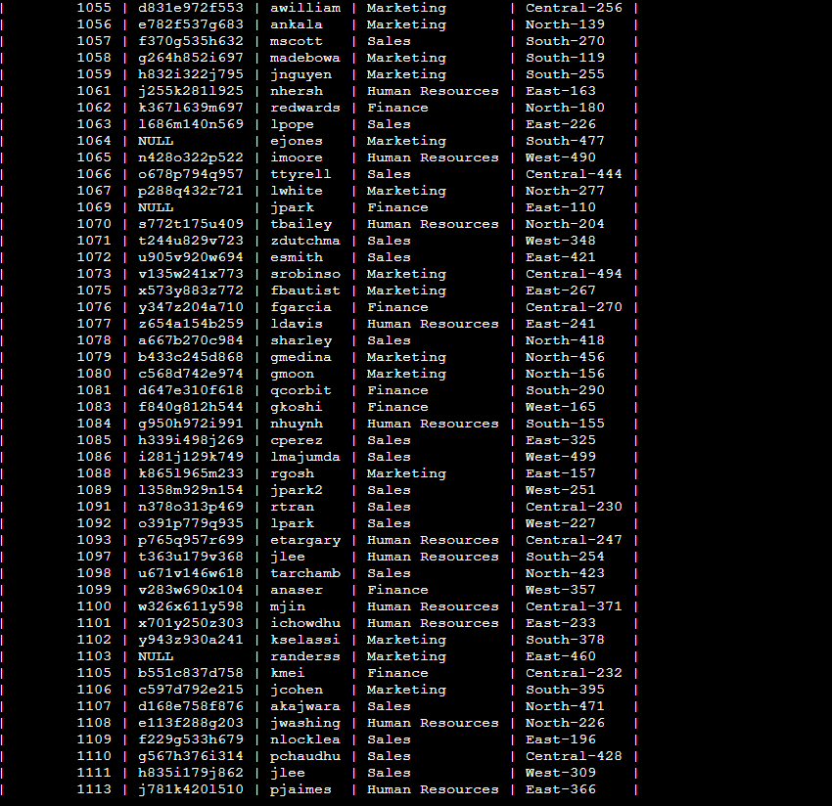
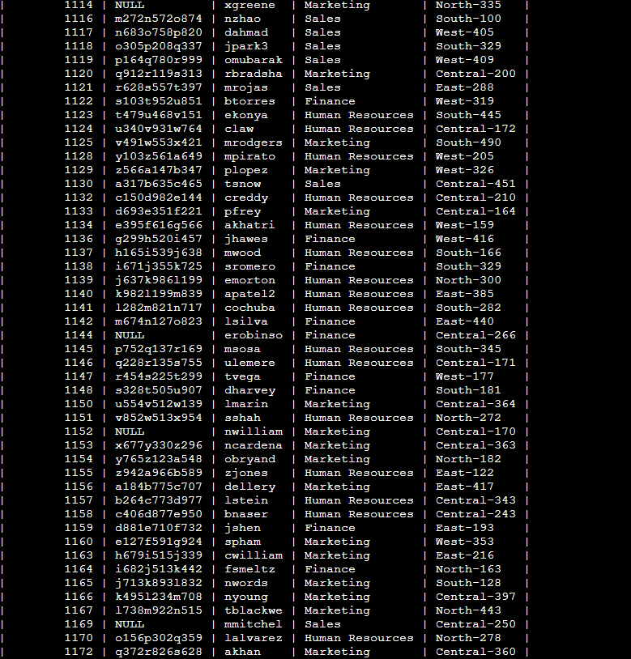
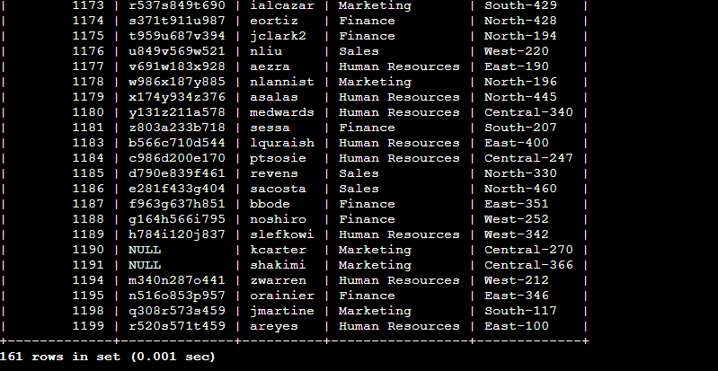
I executed a SELECT * query on the employees table to identify all staff members outside of the Information Technology department. By applying the condition WHERE NOT department = 'Information Technology', I excluded IT personnel from the dataset. The query returned a total of 161 non-IT employee records.

Summary
I queried the log_in_attempts and employees tables using SQL SELECT statements with WHERE, LIKE, AND, OR, and NOT operators. This allowed me to investigate suspicious or anomalous login patterns and filter employee records across specific departments and office locations.

